Dashboardlink <https://public.tableau.com/views/Nmbook/dashboard?:language=en-US&publish=yes&:display_count=n&:origin=viz_share_link>

<https://public.tableau.com/views/Nmbook/Dashboard2?:language=en-GB&publish=yes&:display_count=n&:origin=viz_share_link>

<https://public.tableau.com/views/Nmbook/Dashboard3?:language=en-GB&publish=yes&:display_count=n&:origin=viz_share_link>

Story

https://public.tableau.com/views/Nmbook/Story1?:language=en-GB&publish=yes&:display_count=n&:origin=viz_share_link

<https://public.tableau.com/views/Nmbook/Story2?:language=en-GB&publish=yes&:display_count=n&:origin=viz_share_link>

PROJECT TITLE - INDIA’S AGRICULTURE CROP

PRODUCTION ANALYSIS

1. **Introduction**

This report delves into the captivating realm of India's agricultural cultivation, providing a comprehensive visual exploration of keyaspects and trends in the agricultural sector.

* 1. **Over view**

These visualizations enable intuitive analysis,allowing stakeholders to uncover patterns, identify areas of growth or concern, and make data-drive decisions.

* 1. **Purpose**

High Performance: Users rate Tableau's

overall performance as strong and secure. ...

Mobile-friendly: ...

Extensive Customer Resources: ...

Excellent Mobile Support: ...

Easy to Upgrade: ...

Low Cost: …

1. **Problem statement and design thinking**

* understanding design problems and opportunities
* visualising and generating creative and innovative ideas
* analysing and evaluating those ideas that best meet the criteria for success and planning.
  1. **Empathy map**

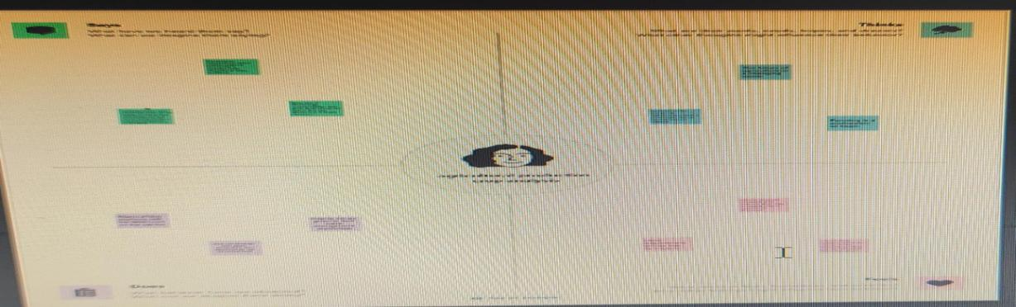

* 1. **Ideation and brainstorming map**

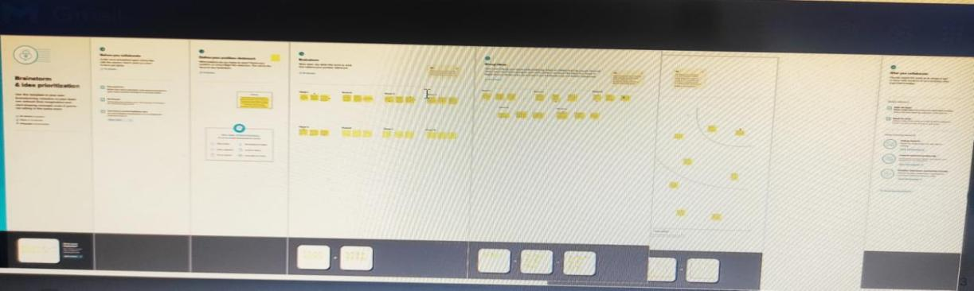

**3.Result**

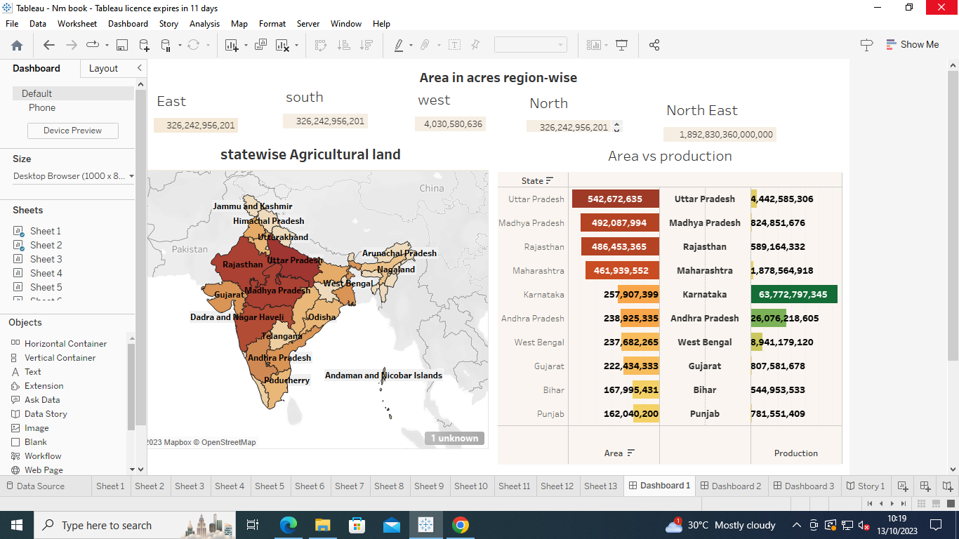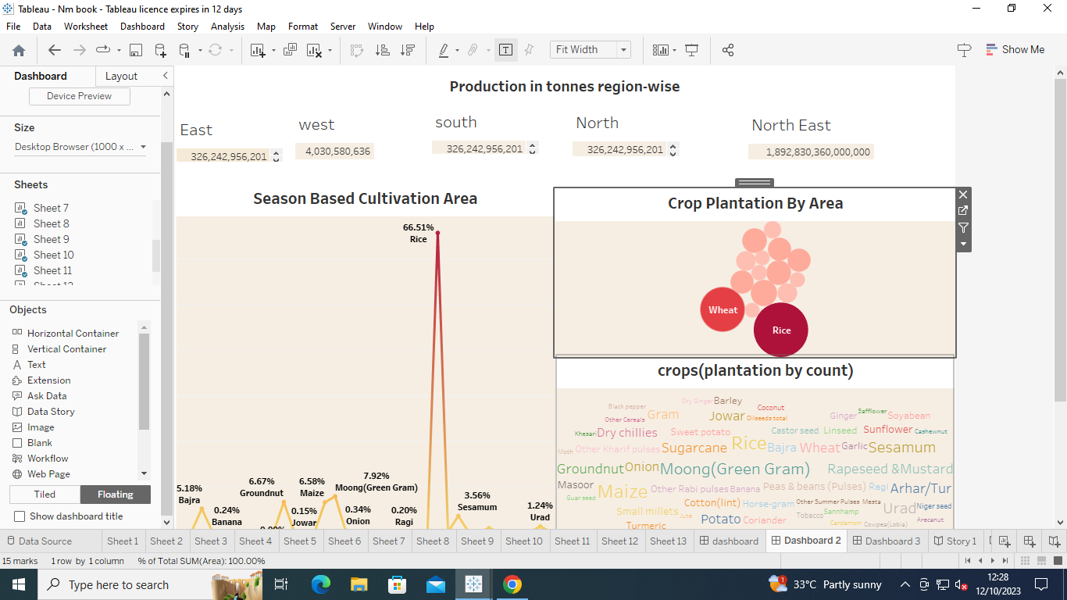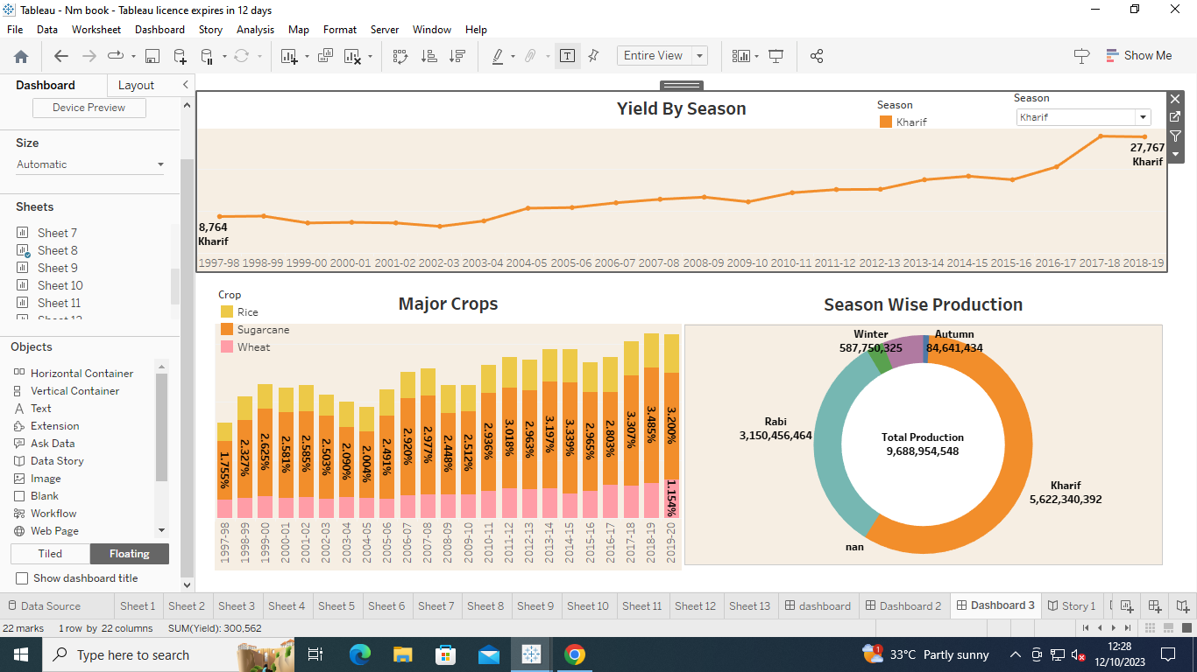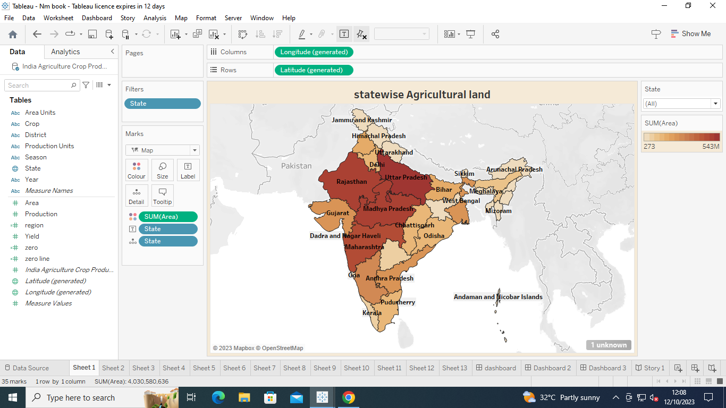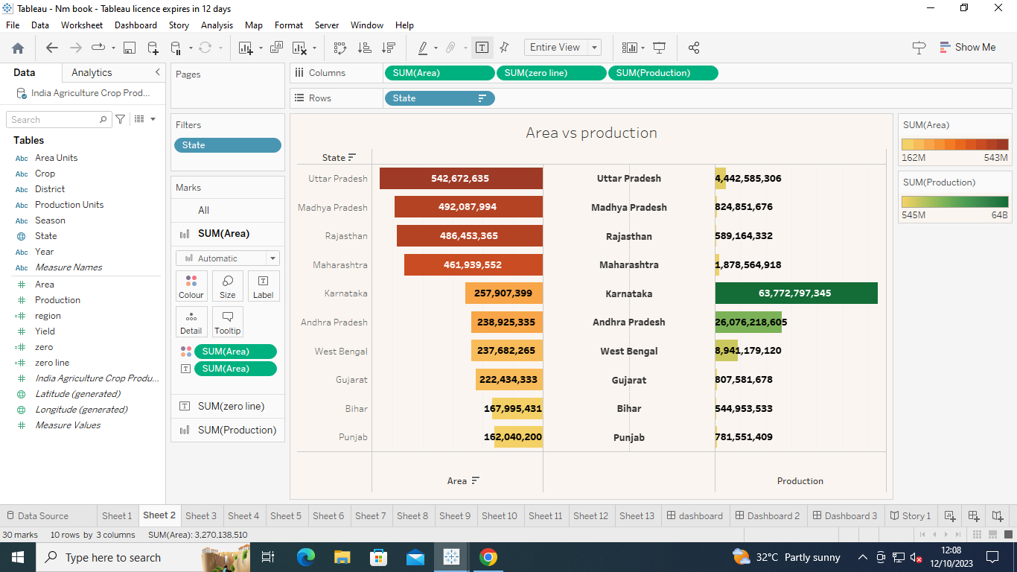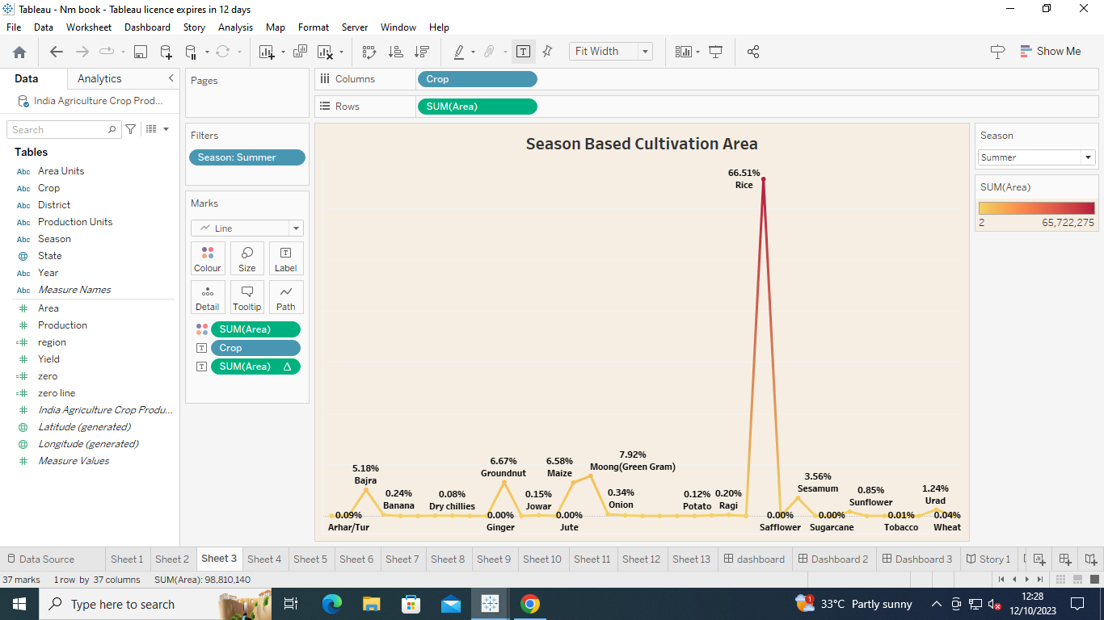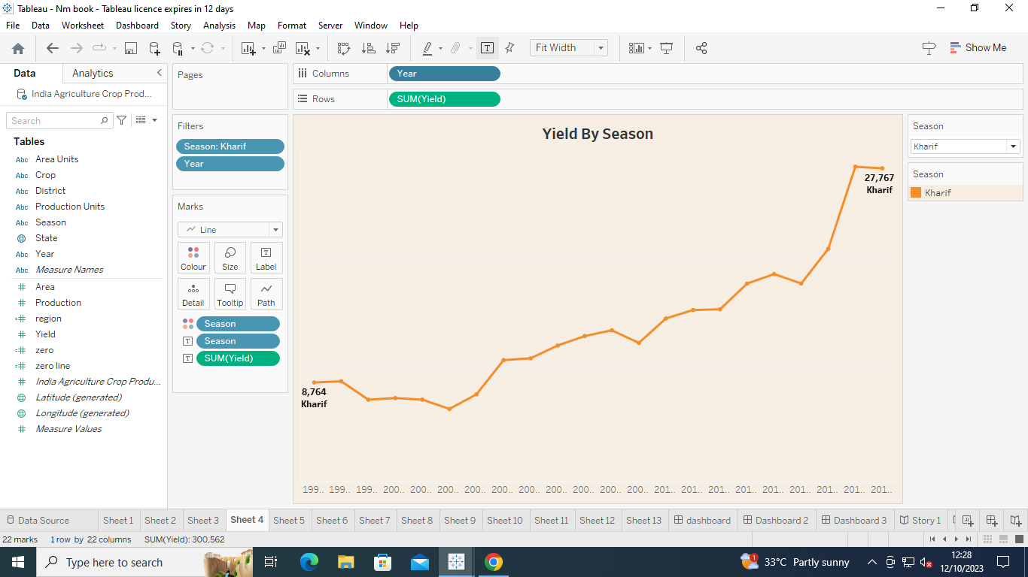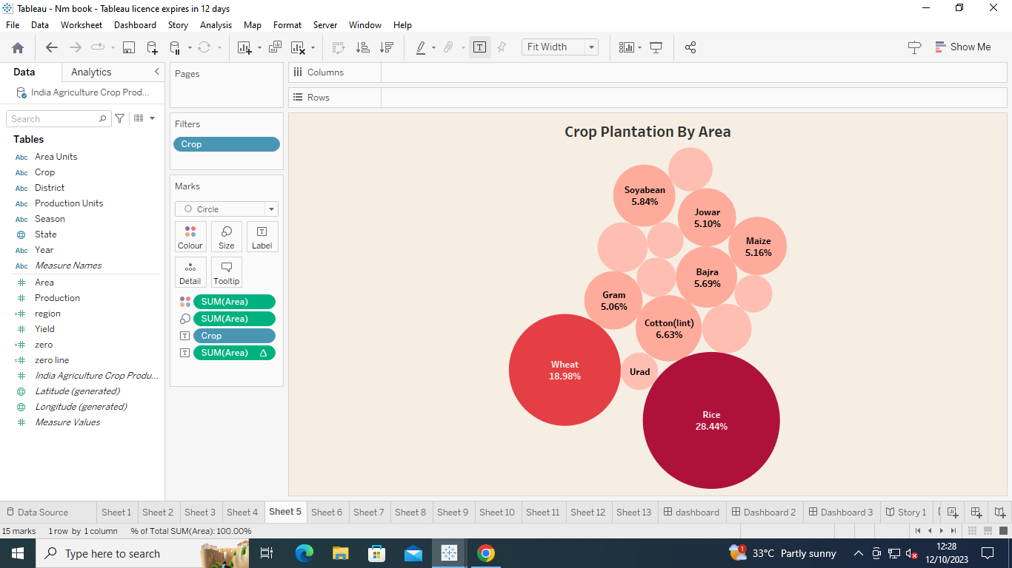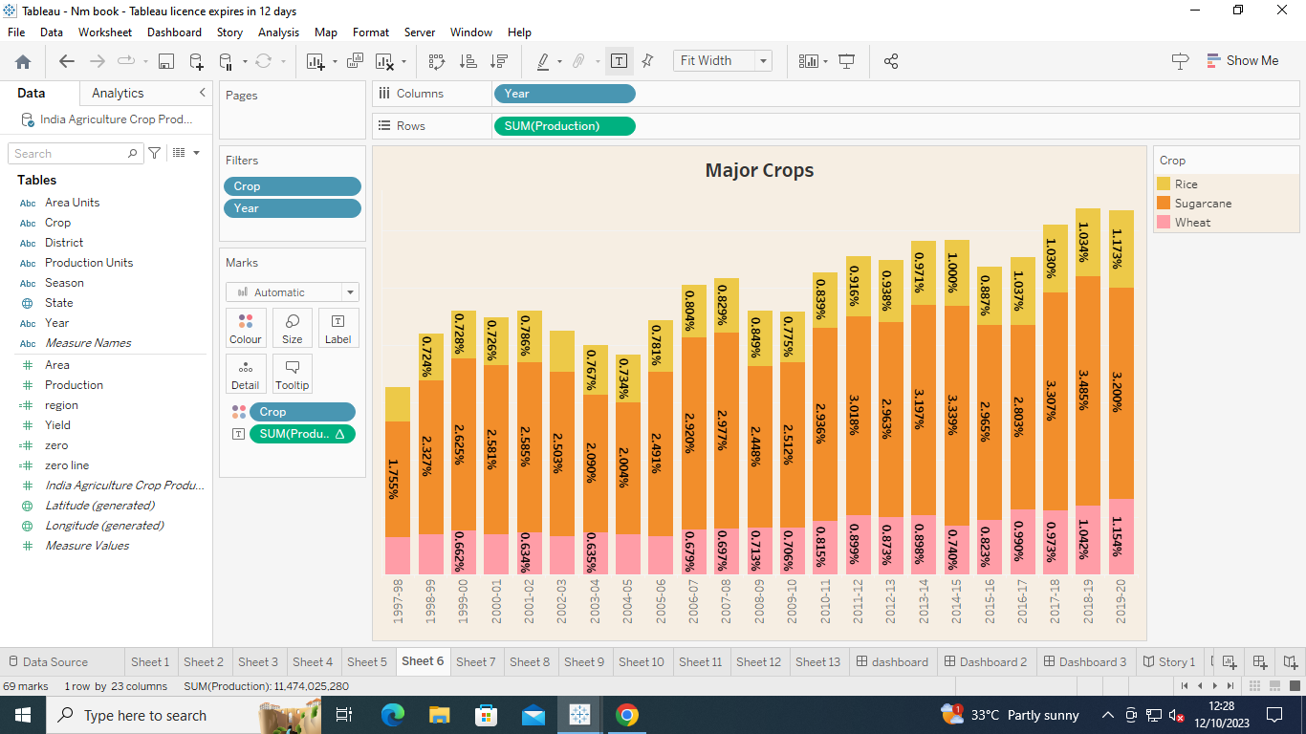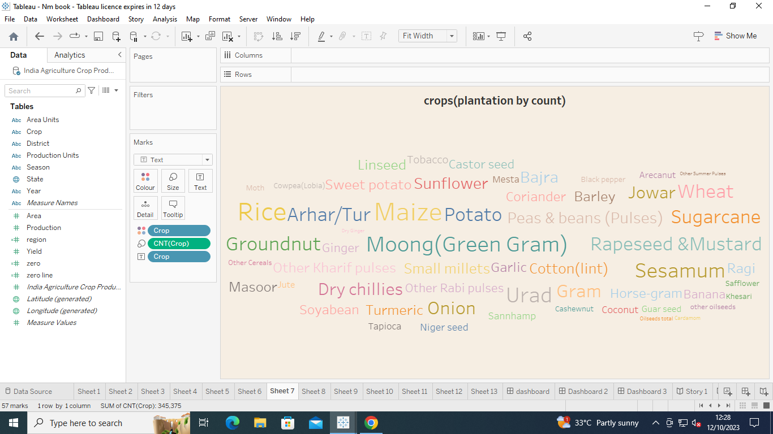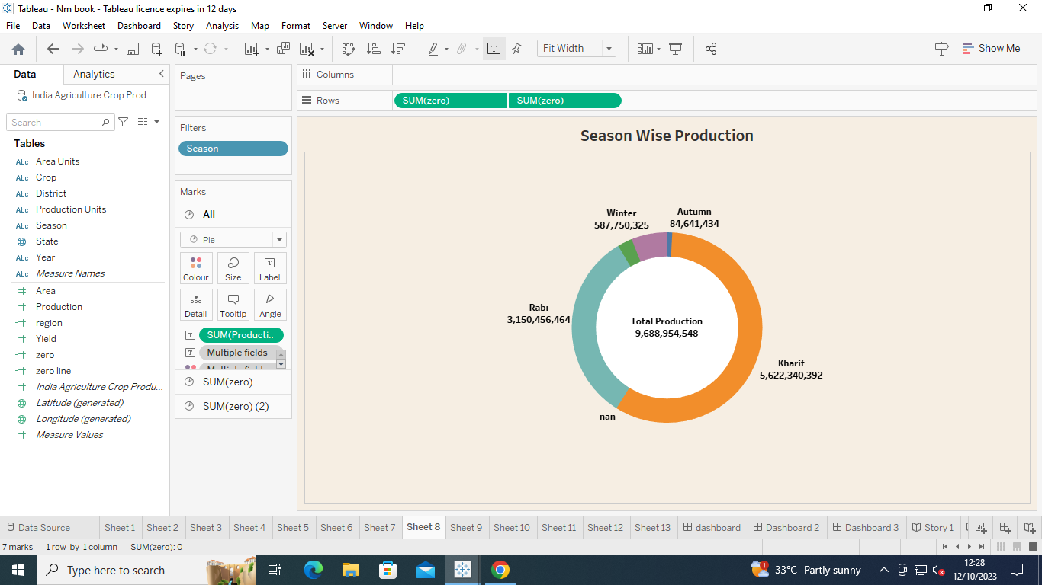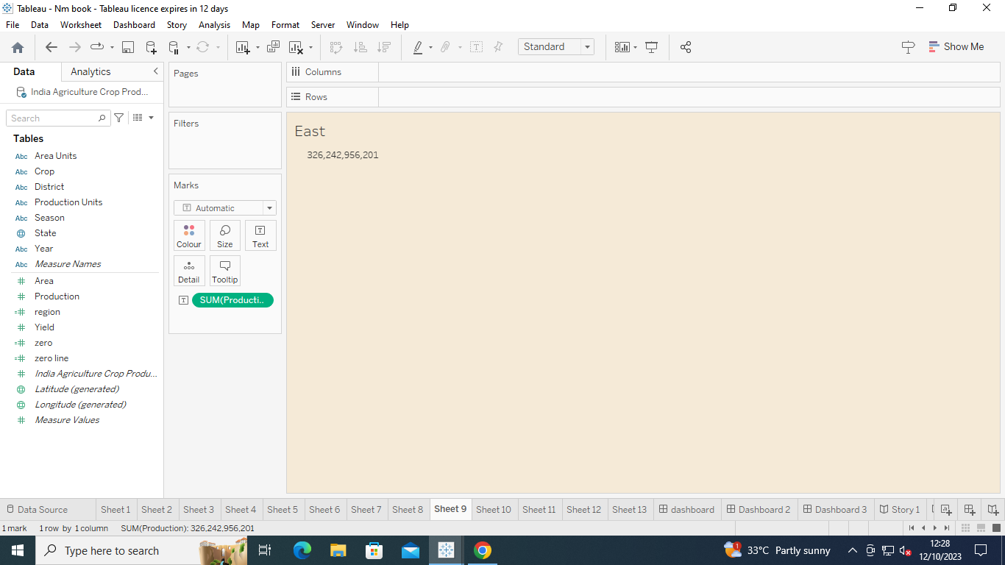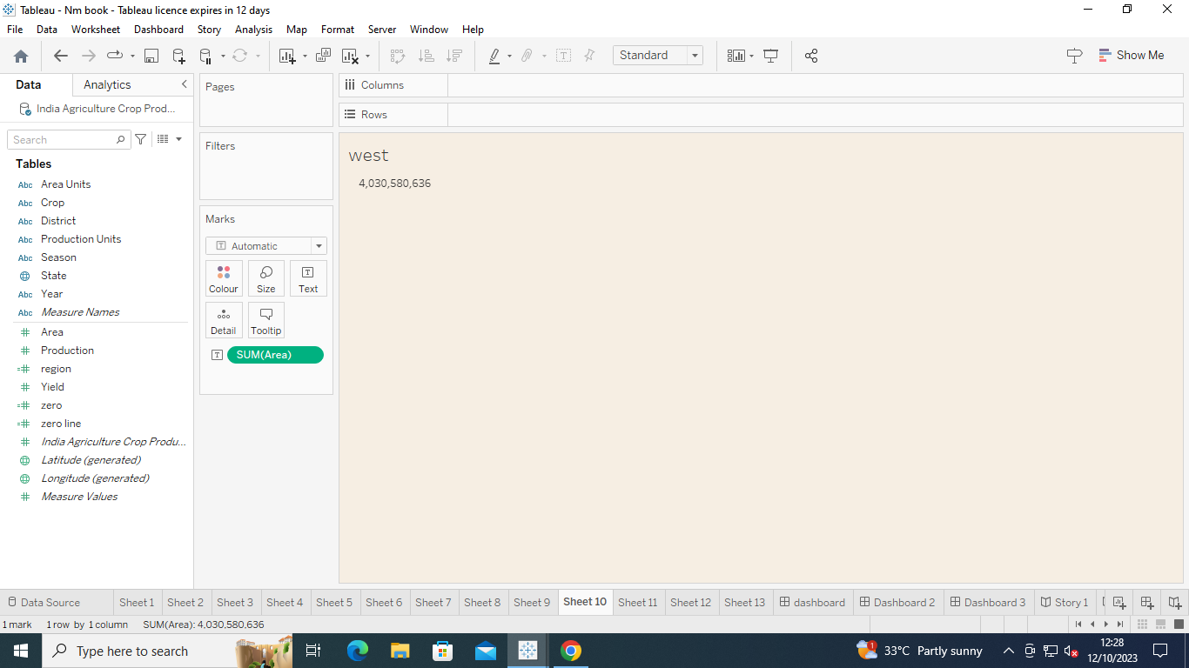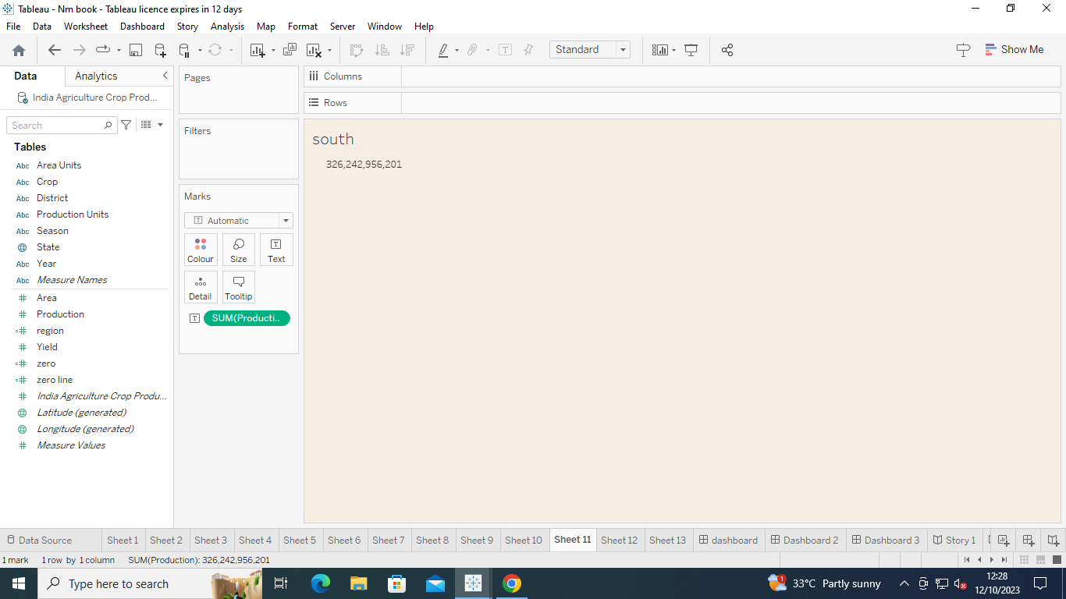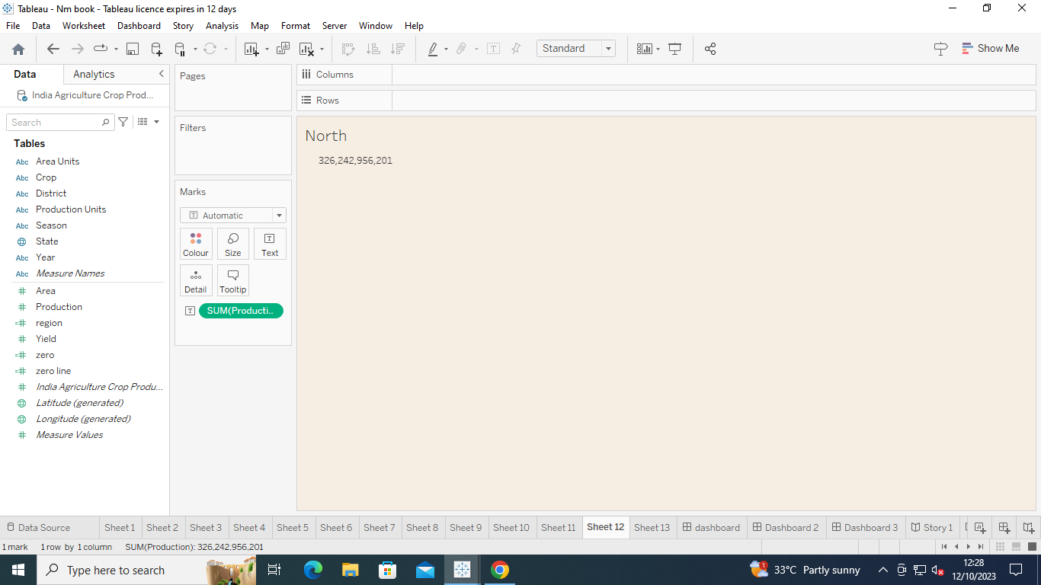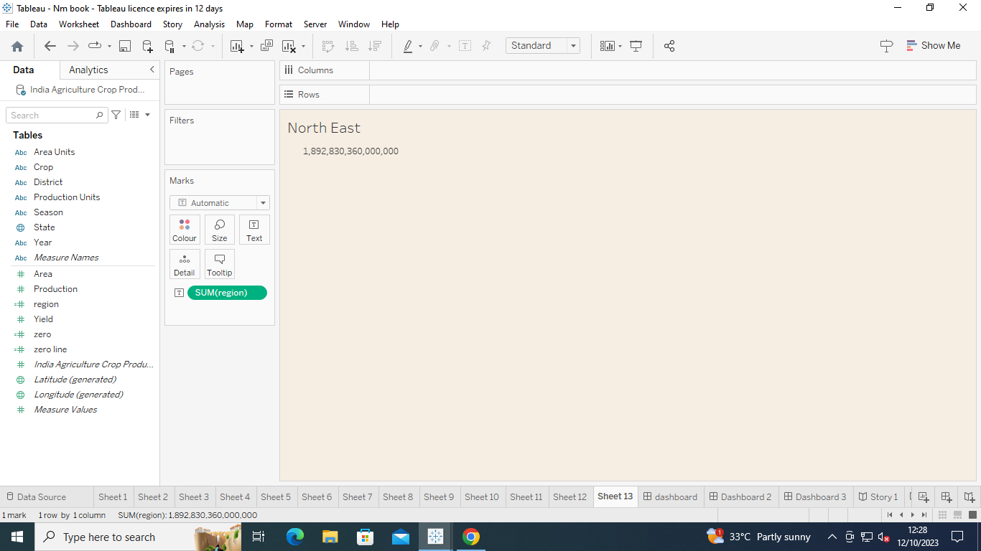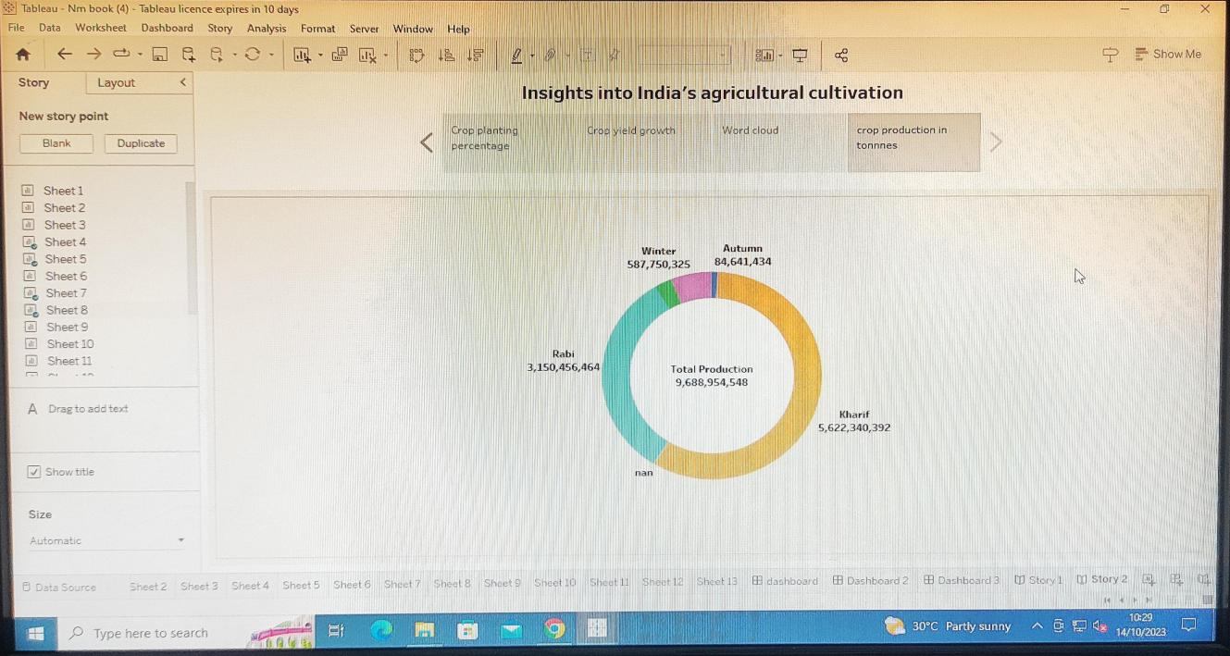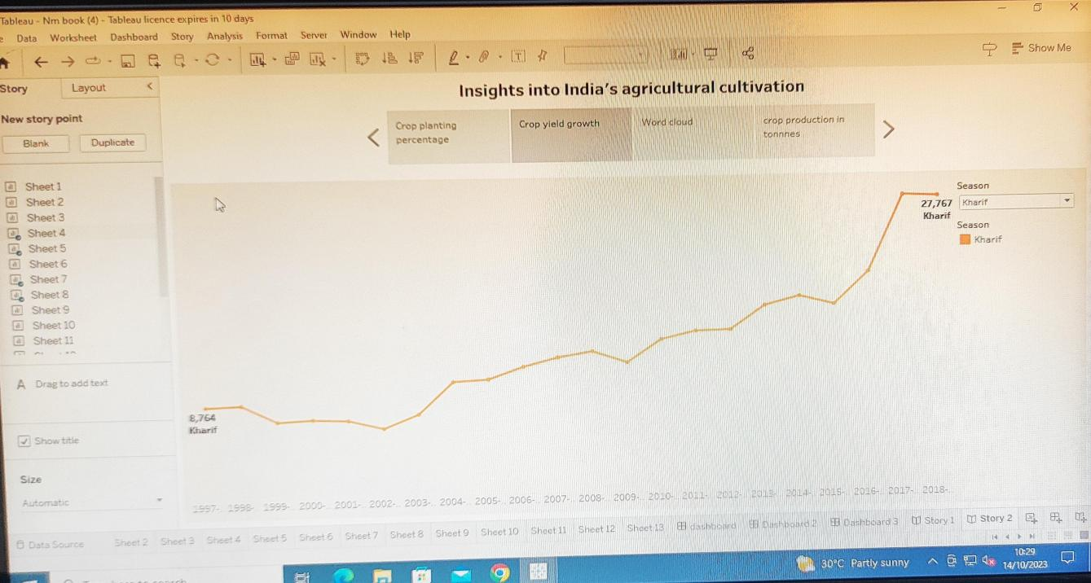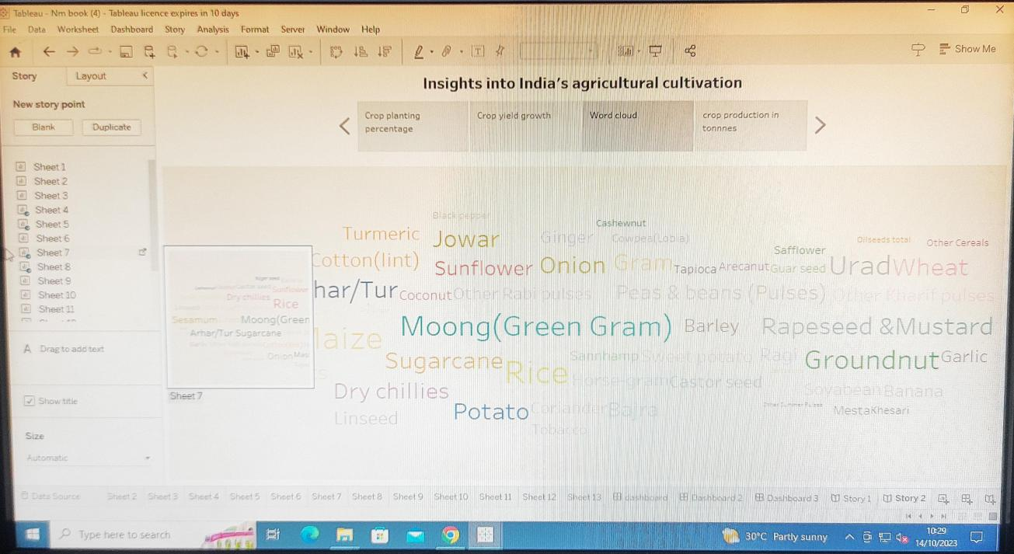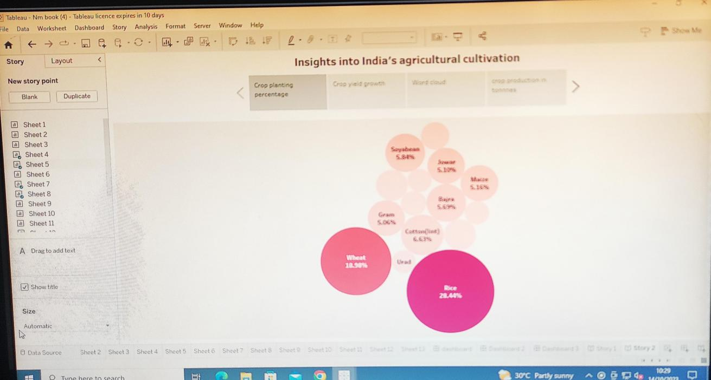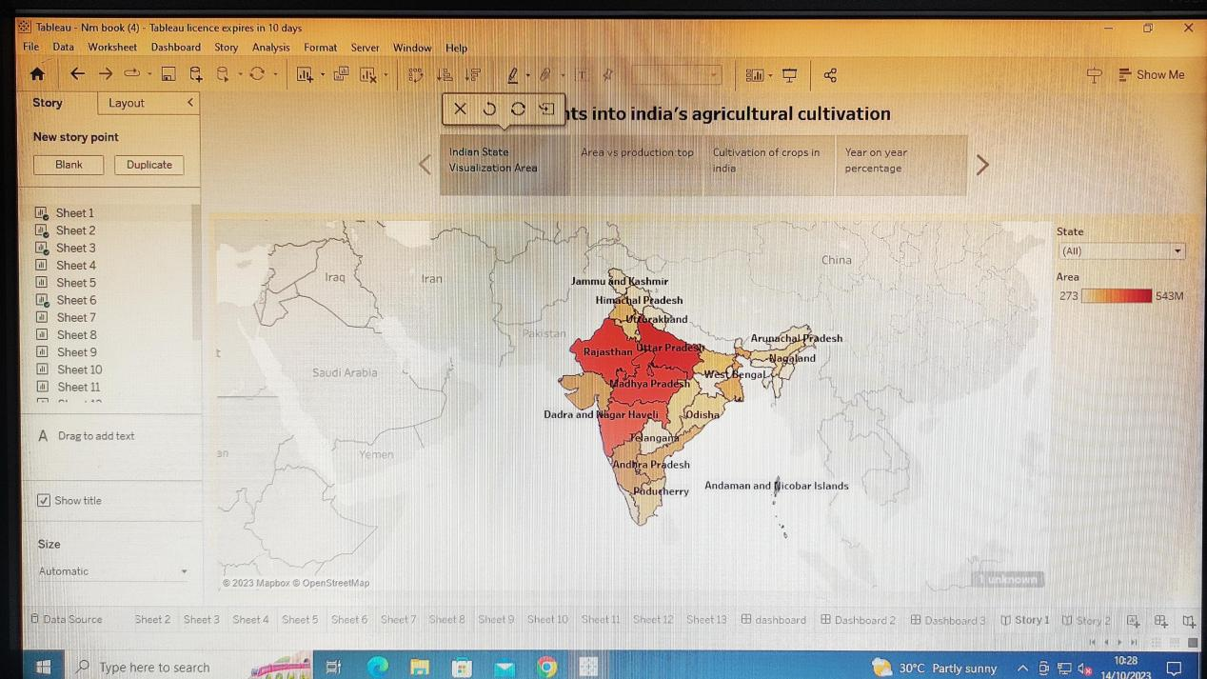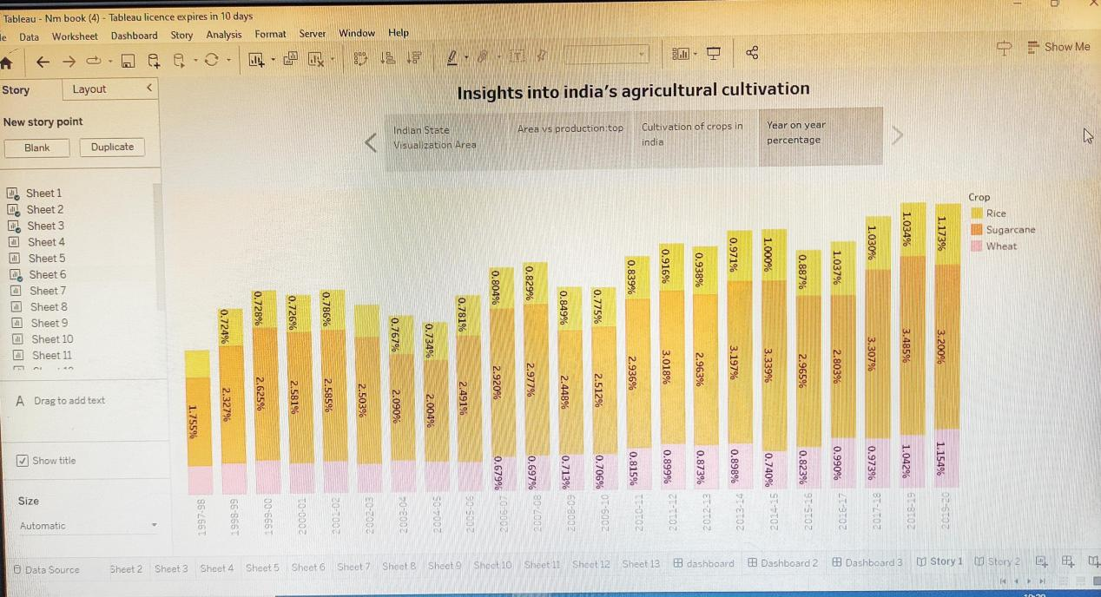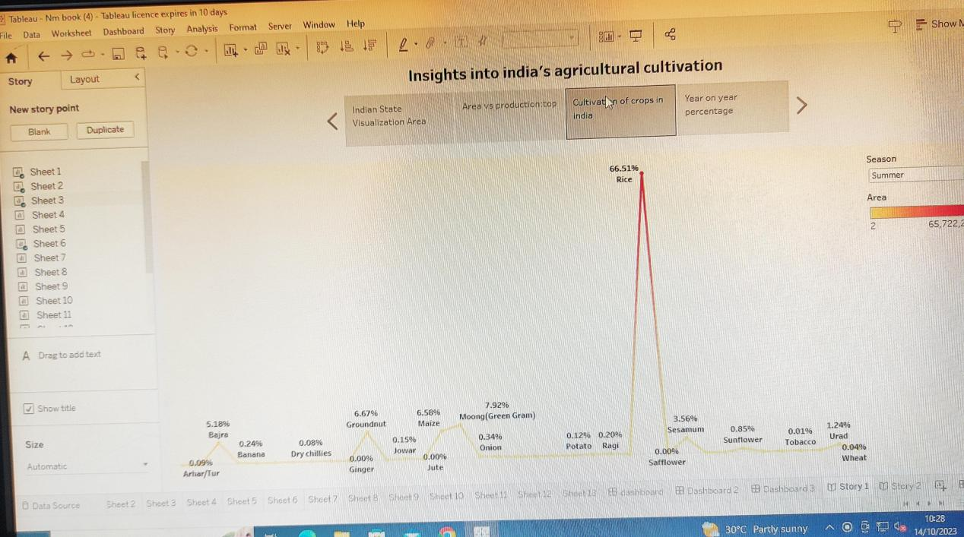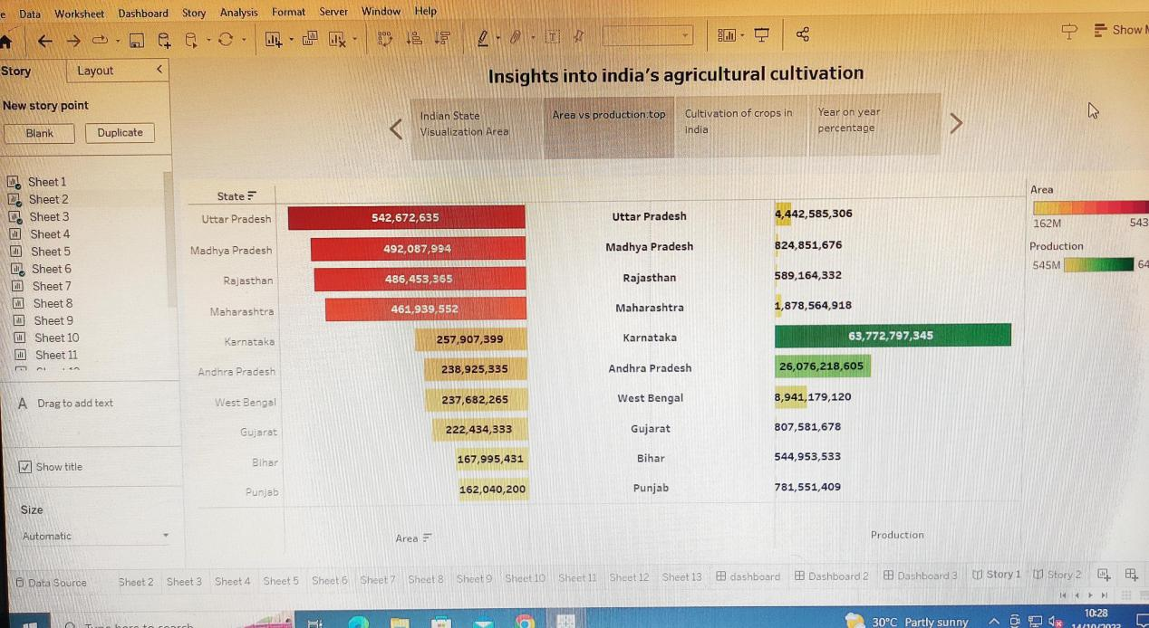

Advantages and Disadvantages

**Advantages.**

Quickly Create, Interactive visualizations,Data visualization

Ease of Implementation:Tableau can handle large amounts of data

**Dis adavantages**

Use of other scripting languages in Tableau

No Custom Visual Imports

Custom formatting inTableau

Static and single value parameters

Use of other scripting languages in Tableau

**Application**

Agriculture crop production

Season wise production list

**Conclusion**

Though the dataset is complex or the dataset is very big, in

tableau, we can create dashboards very easily and within

less time.Tableau is a visual analytics platform transforming the way we use data to solve problems—empowering people and organizations tomake the most of their dataTableau Desktop helps to create reports, dashboards, and stories using different charts and graphs.

**Future scope**

A person with knowledge of Tableau can get many roles like data analyst, business analyst, and Tableau consultant.Further, in Business Intelligence, one can get roles like Business Intelligence Analyst, Business IntelligenceDeveloper, and Business Intelligence Manager, all of which are highly paying roles.Once you become a certified professional in Tableau from a reputable institute, your options are endless.Unlike few other programming languages that give you limited scope, this one has incredible scope and opportunities.